

Πανεπιστήμιο Πειραιώς
Σχολή Τεχνολογιών Πληροφορικής και Τηλεπικοινωνίων
Τμήμα Ψηφιακών Συστημάτων

Επίπεδο: Προπτυχιακό/Μεταπτυχιακό Πρόγραμμα Σπουδών

ΑΣΦΑΛΕΙΑ ΔΙΚΤΥΩΝ

Lab 1 exercise
Επιβλέπον Καθηγητής: Χρήστος Ξενάκης

Ονοματεπώνυμο | E-mail | A.M.
Έλβις Αβντούλι | avdulielvis@gmail.com | E22001

Πειραιάς
25/10/2024

Contents
Step 1: Changing Routers’ hostnames 1
Step 2: Configure Network 1
Step 3: Configure PC’s Address 3
Step 4: Configure IP Route 5
Results 6

Step 1: Changing hostnames

To change hostnames, we can use the command line after pressing the router. The first thing we must do is to run the CLI as the root user. To do that, we must type “en”. Then we press “conf t” (configure terminal) so we enter the global configuration mode.
Then using the command “hostname <<name>>” we can change the routers’ hostnames. So, we change the hostnames to “Rooter0” to “Rooter1”

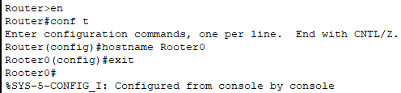
Changing the hostname of “Router0” to “Rooter0”

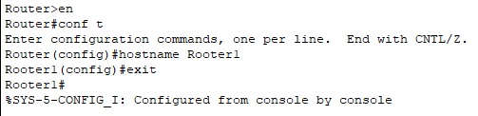
Changing the hostname of “Router0” to “Rooter0”

STEP 2: Configure network

To configure a network, we must run as a user like before and configure terminal. Then, we must select to configure the link between a router to another router, or a router to pc etc. using the command “int <<link>>”. For example, to configure the link of Router0 and Alice, we must type “int g0/0”. Also, we must use the command “ip address <<IP>> <<Subnet Mask>>” to configure the network. Lastly, we must type “no shut” enable an interface on a router or switch.
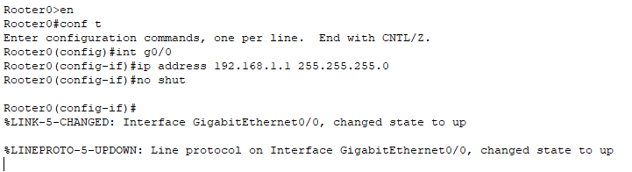
Configure Alice’s network

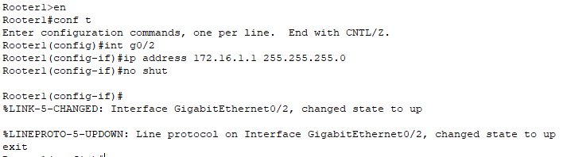
Configure Bob’s network
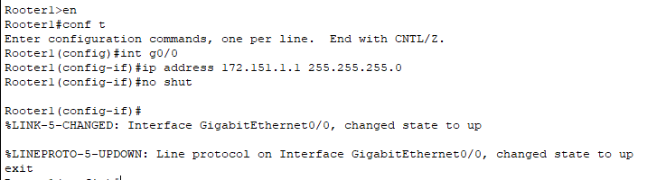
Configure Charlie’s network

To configure the network between 2 routers we do same as before, though these actions must be done both for Rooter0 and Rooter1. We will set the IP address of the Rooter0 as 10.0.0.1 and Rooter2’s IP address as 10.0.0.2
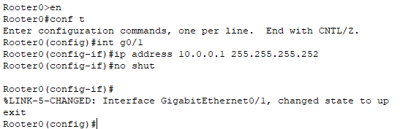
Configure Network 10.0.0.0/30 Rooter0

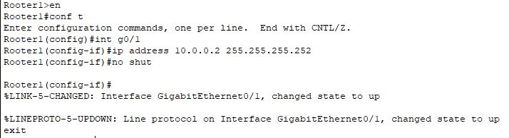
Configure Network 10.0.0.0/30 Rooter1

STEP 3: Configure PC’s address
To configure a PC’s, Address the PC must be selected. Then, by clicking the “Desktop” and the “IP address” option we can set the address for the PC, as well as the subnet mask and the default gateway.

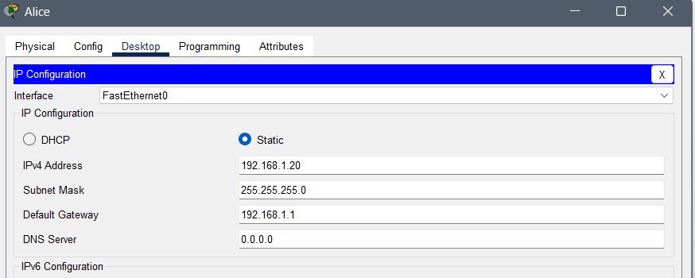
Configure Alice’s IP address
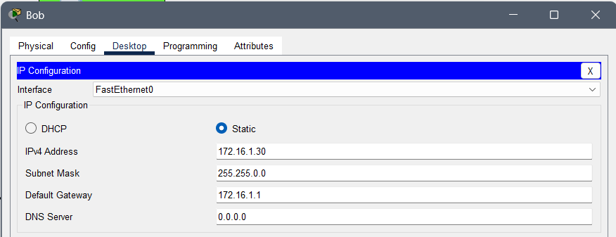
Configure Bob’s IP address

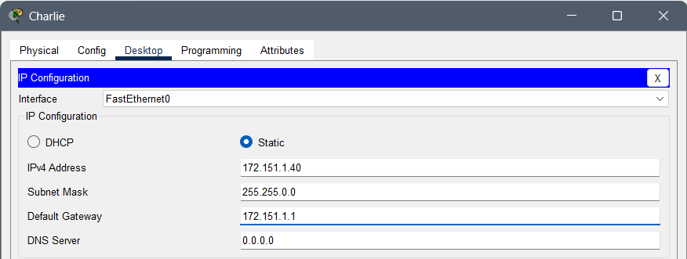
Configure Charlie’s IP Address

Now everything should be up by now but there is only one step left

STEP 4: Configure IP Route

To configure IP route, a router must be selected. Then by using the CLI, running as a root (like before) and configuring terminal, a command is only needed. “ip route <<network’s destination IP>> <<networks destination subnet mask >><<routers IP>>” will root the message from one PC to another network via the router we select. For example, the commands in our case are:

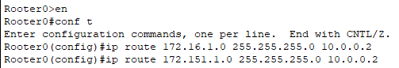
From Alice’s network to Bob’s and Charlie’s network

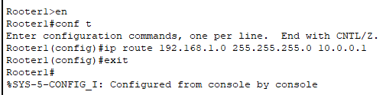
From Bob’s and Charlie’s network to Alice’s network

RESULTS
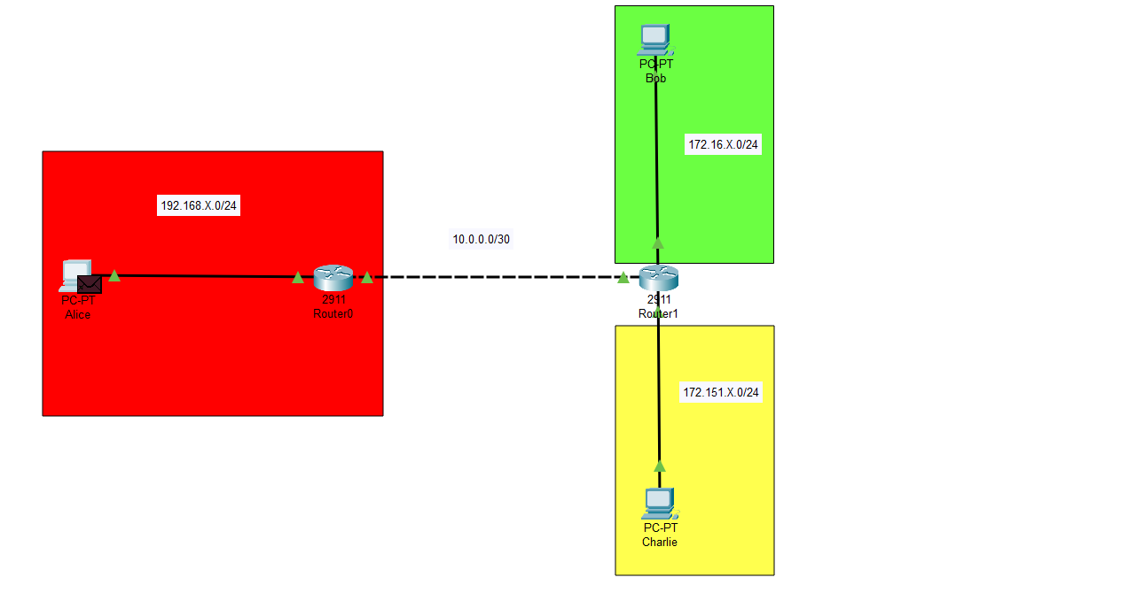
In order to test our network, we will send a ping command through the cmd of a PC to see if it reaches its destination

Ex1. From Alice to Bob
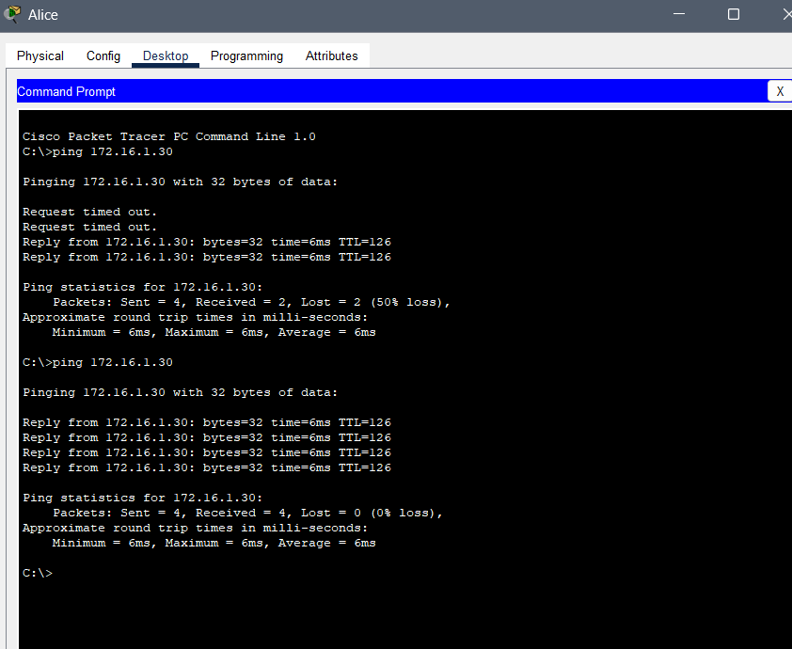
Ex. 2 From Alice to Charlie
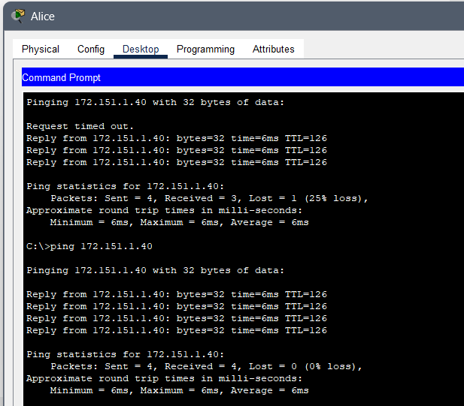

Ex.3 From Bob to Charlie
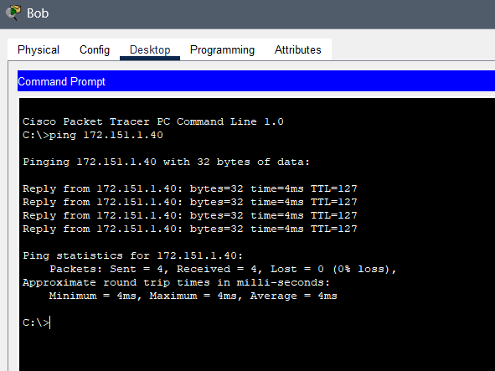

As a result, we can send from anyone to anyone, so the network is working correctly

